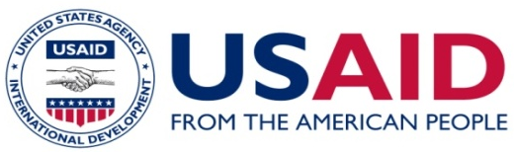

News Release:
South Asian Task force Members are convening at Thimphu,Bhutan on 4th and 5th June,2014 to address legal, Regulatory and Policy issues concerning Cross Border Electricity Trade (CBET) and find out possible solutions.
New Delhi, May, 23, 2014 – Integrated Research and Action for development (IRADe) under Cooperative Agreement with USAID’s South Asia Regional Initiative for Energy Integration Program (SARI/EI), is convening meeting of Task Force Members of South Asian members at Thimphu, Bhutan on 4th and 5th June to address the legal, Regulatory and Policy issues concerning Cross Border Electricity Trade (CBET) and find out possible solutions to advance Cross Border Electricity Trade in South Asia.
The meeting is expected to discuss the interim findings of study report on review of existing Acts, Policies and other regulations and agreements and seek suggestion from the members on interim findings and come out with preliminary recommendations on changes to be made in regulatory, legal, policy aspects for promoting CBET. This Meeting is also expected to discuss and deliberate on Investment related issues. The development of set of coordinated policies, procedures and regulations and integrated regional network planning is a key “building block” to facilitate competitive cross-border trading in electricity and development of regional power market in south Asia.
The Task Force-1 members consists of Senior level Officials nominated by South Asian Country Government and are working on Coordination/Harmonization of legal, Regulatory and Policy issues concerning Cross Border Electricity Trade (CBET). Task Force is expected to create an enabling conditions for a sustainable market for investment and implementation of cross-border electricity trade and strive to establish the legal and regulatory framework through identification of areas of major inconsistency in their acts, policies such as licensing, import/export policies, tariff policies, etc. for development of regional power market in south Asia.

For additional information please contact:
Rajiv Ratna Panda,
Sr. Project Manager, SARI/EI, IRADe,
rajivpanda@irade.org

